**Promises, promises: What happened to loan forgiveness?**

*(26 million borrowers want to know!)*

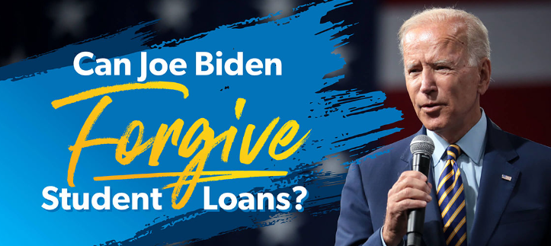

*Graphic:Ramsey Solutions*

**Unfulfilled promises to date!** Are you one of the 26 million borrowers who applied for loan forgiveness or the 16 million who received email notifications that your request had been approved by the Education Department (ED)? What happened? Has the program been cancelled? What should I expect in 2023?

**What were the “promises” for this loan forgiveness program?** The loan forgiveness’s promise was intended to provide relief for struggling borrowers. It offered up to $20,000 of debt relief for Pell Grant recipients and $10,000 of debt relief to eligible single borrowers of federal loans earning less than $125,000 or $250,000 per household.

**Why did the Biden administration halt the program?** The short version is that the program was successfully challenged in the courts. The next step is a scheduled review by the Supreme Court in February with a final decision expected to be issued by spring. (The majority of experts are not optimistic about a ruling in favor of the Biden plan!)

**How can I prepare for the resumption of payments?** The good news is that borrowers still have time to prepare for a worst-case scenario of a resumption of payment in June. Additionally, the Education Department (ED) is in the process of rolling out a new, more generous Income Driven Repayment Plan (IDR) plan that reduces payments by 50%. (More details to come in February, and I welcome questions!)

*Robert J. Miller Financial Literacy Advocate for Women’s Money Matters*

The promise was to provide loan relief to 40 million borrowers with up to $20,000 (Pell Grant recipients) and $10,000 for the majority of eligible federal loan borrowers. The plan was barred by the courts, and the Supreme Court is scheduled to review the case in February with an expected decision by late spring.

*Biden’s one-time student loan debt relief plan would provide $10,000 in student loan forgiveness for many borrowers with government-held federal loans. The amount of debt relief can double (to $20,000) for borrowers who received Pell Grants when they went to school. To qualify, single and married-filing-separately borrowers must have earned under $125,000 in Adjusted Gross Income in either 2020 or 2021; that income cap doubles for borrowers who are married and filed their taxes jointly: Minsky Notes*

Biden’s program would offer up to $20,000 of debt relief to millions of qualified borrowers, but it has been met with legal challenges since it was announced.

Last month, the Biden administration [began notifying people](https://www.cnn.com/2022/11/19/politics/student-loan-debt-relief-biden-notices/index.html)who are approved for federal student loan relief. About 26 million people had already applied to the program by the time it was frozen prompting the government to stop taking applications. No debt has been canceled thus far.

In the case at hand, Solicitor General Elizabeth Prelogar had urged the justices to lift a block on the program and hear oral arguments this term. They agreed only to the latter request.

The program is designed to aid borrowers who are at highest risk of delinquency or default. Once debt cancellation begins, the plan could offer up to $10,000 in student loan debt relief to eligible borrowers making less than $125,000 ($250,000 per household.)

In addition, borrowers who received a [Pell grant](https://www.cnn.com/2022/08/25/politics/pell-grant-student-loan-forgiveness/index.html) can receive up to $20,000 in relief.

About 26 million Americans have applied for student loan forgiveness since August, and the U.S. Department of Education has already approved requests from 16 million. The government [stopped taking](https://www.reuters.com/world/us/us-student-loan-debt-relief-blocked-2022-11-11/) new applications Nov. 11, after the Texas judge blocked Biden's order.