**Updates on Public Student Loan Forgiveness (PSLF)**

(Don’t give up on the 10-year PSLF loan forgiveness plan!)

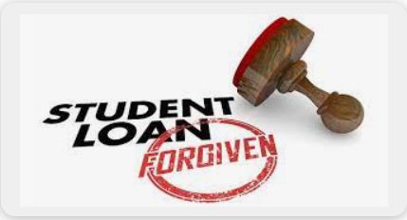

Graphic: Protect 17

**Who is eligible for PSLF loan forgiveness**? This government program was established to provide a pathway for educators, government employees and workers in the non-profit sector, like WMM, to obtain loan forgiveness for federal loans. The key eligibility requirement is to work full-time for a qualified employer for 10 years or submit 120 payments. Eligible participants are required to submit an Employment Certification Form (ECF) signed by each employer to verify your employment. (If you have questions about your eligibility, consider using the PSLF Help Tool: <https://studentaid.gov/pslf/#!/pslf/launch>.)

**PSLF has NOT been impacted by the halted Biden loan forgiveness program?** The PSLF loan forgiveness program continues to provide loan relief for eligible borrowers on a daily basis. To date, over 350,000 borrowers have received loan forgiveness. I have heard from scores of educators and workers in the non-profit sector who received loan forgiveness and even refunds for making more than 120 payments!

**What should I do if submitted my PSLF application 6 months ago and haven’t heard anything?** Unfortunately, Mohela, the ONE designated servicer for processing all PSLF applications, has been overwhelmed by the volume of applicants. According to the Education Department (ED), it may take until the middle of the summer to process all applications. Be patient; they will be processed!

**What if I my application was rejected?** It’s possible that your application was unfairly rejected. (The improved more borrower-friendly PSLF has removed many unnecessary barriers and made it easier for borrowers to get credit) Strongly consider submitting another request to Mohela. One common problem is that applicants will be required to submit additional information on why your not-for-profit employer meets the eligibility requirements. (Here’s a link to the reconsideration of payments student aid website: <https://studentaid.gov/announcements-events/reconsideration-for-pslf>)

In the coming months, I plan to post articles about the new IDR repayment plan, relief for low-income borrowers and defrauded borrowers and the “Fresh Start Initiative” for delinquent borrowers.

Robert J. Miller, Financial Literacy Advocate for Women’s Money Matters